CSC 4120/6120 INTRODUCTION TO ROBOTICS

### MODULE 5

### All source codes for GoPiGo 3 robot are available in the GitHub page: <https://github.com/DexterInd/GoPiGo3>

### **Object Avoidance**

Distance sensor required + Servo needs to be properly configured. It is ideal to place the distance in alignment with the servo as shown below so that we can have full viewing angle whilst servo rotation.

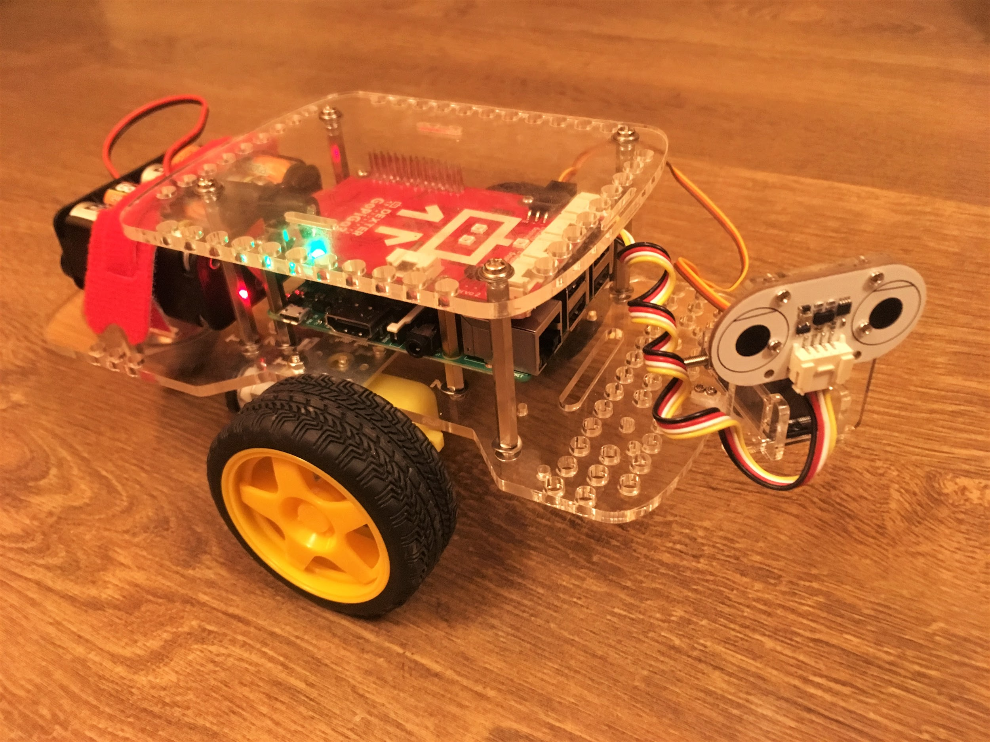

**Exercise 1**: **IntelligentObjectAvoider**

In this exercise we will see how to avoid objects as the robot moves.

On the Terminal, type:

#### cd GoPiGo3-Projects/IntelligentObjectAvoider

#### python3 robot.py

Result:

The robot should be able to avoid objects and move away. You can create a little maze and check if robot successfully steers away and traverses in desired way.

Refer Module 5, Exercise 1 for video on this exercise.

**Exercise 2**: **ObjectAvoidanceRobot**

In this exercise we will see how the robot should detect an object or an obstacle and come to a complete halt. Once the object is eliminated or moved away, it should continue along the path.

On the Terminal, type:

#### cd GoPiGo3-Projects/ObjectAvoidanceRobot

#### python3 object_avoidance_robot.py

Result:

Place an object with a reasonable distance and check if robot detects and halts. After a few seconds remove the object and see if the robot moves now.

Refer Module 5, Exercise 2 for video on this exercise.